
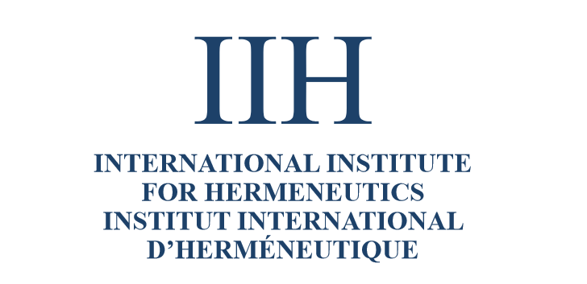


International Conference
on Hermeneutics, Education, Law, and Medicine
Ars Interpretandi:
Existentia Hermeneutica
between
the Text Worlds

May 29-31, 2020
Zakopane
al. Przewodników Tatrzańskich 2

For more information please contact
andrew.wiercinski@gmail.com

