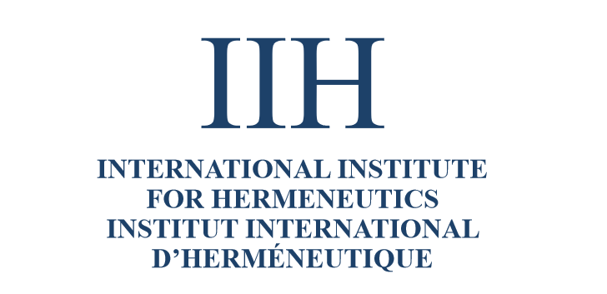
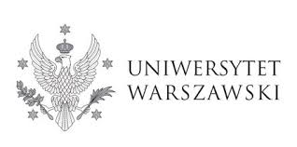


International Conference
on Hermeneutics, Education, Law, and Medicine
Ars Interpretandi:
Hermeneutic Conversation
between
the Text and Its Reader

May 25, 2019
Zakopane
al. Przewodników Tatrzańskich 2
Conference Program

9.45-10.00 Opening Remarks

Prof. Anna Wiłkomirska, Dean of the Faculty of Education, University of Warsaw, Poland

10.00-11.00: Section 1

Moderator: Andrzej Wierciński, University of Warsaw, Poland
andrew.wiercinski@gmail.com

Ramsey Eric Ramsey, Arizona State University, USA
rer@asu.edu
Language as the Address to the Human Pose

Urszula Zbrzeźniak, University of Warsaw, Poland
urszulazbrzezniak@gmail.com
On the Textuality of Experience of the World and the Self

11.00-11.30: Coffee Break

11.30-12.30: Section 2

Moderator: Diane Gruber, Arizona State University, USA
dgruber@asu.edu

Małgorzata Przanowska, University of Warsaw, Poland
mprzanowska@uw.edu.pl
Acouo-hermeneutics: Reviving (In-)Formation in the Age of Deafness

Małgorzata Hołda, Częstochowa University of Technology, Poland
margaret.c.holda@gmail.com
The Quagmire of the Broken Universe: The Limits of Interpretation

12.30-13.30: Section 3

Moderator: Tracey Sands, Arizona State University, USA
tsands3@asu.edu

Jordan Huston, Fordham University, USA
jordanjhuston@gmail.com
Phronetic Fidelity: A Hermeneutics of Transformation

Andrzej Wierciński, University of Warsaw, Poland
andrew.wiercinski@gmail.com
The Fragility of Consciousness: The Call of Conscience as Dasein’s Call to Itself (Seinkönnen)

Wojciech Cyrul, Jagiellonian University, Kraków, Poland
wojciech.cyrul@jci.pl
Hermeneutics of Hypertextuality: Legal Text and its Readers

13.30-15.00: Lunch Break

15.00-16.00: Section 4

Moderator: Elise Poll, Barrett, Arizona State University, USA
epoll@asu.edu

Andrej Božič, Nova Revija Institute for the Humanities, Ljubljana, Slovenia
bozic_andrej@yahoo.com
“… wound-read.” The Healing of Words: A Hermeneutic Reading of Paul Celan’s Poetry

Paulina Sosnowska, University of Warsaw, Poland
psosnowska@uw.edu.pl
Solidarity and Impartiality in the Ambiguity of Action

16.00-17.00: Section 5
Moderator:
Alenka Koželj, University of Ljubljana, Slovenia

Wojciech Hanuszkiewicz, Pedagogical University of Cracow, Poland
wojciechhan@wp.pl
The Im-possibility of Education

Kamil Kołodziński, University of Warsaw, Poland
k.kolodzinski@student.uw.edu.pl
Mis-conception of the Medical Practice

Lisa Watrous, Barrett, The Honors College, Arizona State University, USA
Lisa.Watrous@asu.edu
Patchwork Hermeneutics and Theological (Mis)understanding

17.00-18.00 Plenary Discussion
information about the conference:
Marcin Rebes
phone + 48 606-755-354
e-mail: marcin.rebes@uj.edu.pl

