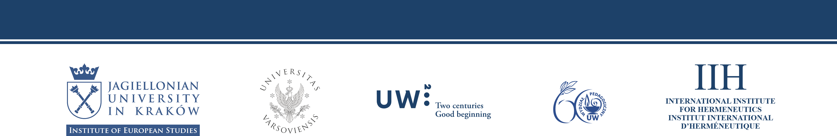
have the honor to invite to an international conference
on hermeneutics, education, and European politics
The Politics of Reconciliation: Phronetic Education, Law, and Medicine
which will take place June 2, 2018 at the Przegorzały Castle
in the Institute of European Studies of the Jagiellonian University (Jodłowa st. 13)
Conference Program

9.45-10.00 Opening Remarks

Dr hab. Krzysztof Koźbiał, Deputy Director for Education, Institute of European Studies, Jagiellonian University, Poland

Prof. Anna Wiłkomirska, Dean of the Faculty of Education, University of Warsaw, Poland

10.00-11.00: Section 1

Moderator: Andrzej Wierciński, University of Warsaw, Poland

Ramsey Eric Ramsey, Arizona State University, USA
Engaging Poetry and Tradition as a Contribution to Phronetic Education

Andrej Božič, Nova Revija Institute for the Humanities,
Ljubljana, Slovenia
The Anti-Politics of Voice: Paul Celan’s Cycle of Poems "Stimmen"

Tyler Tritten, Gonzaga University, USA
Manderlayand the Aporia of Freedom and Responsibility

11.00-11.30: Coffee Break

11.30-12.30: Section 2

Moderator: Diane Gruber, Arizona State University, USA

Paulina Sosnowska, University of Warsaw, Poland
Phronesis and Sophia: Heidegger Reading Aristotle

Wojciech Hanuszkiewicz, The Pedagogical University of Cracow, Poland
Moral Education and the Problem of Personal Autonomy from the Perspective of the Liberal-Communitarian Debate

Małgorzata Hołda, Jesuit University Ignatianum, Krakow, Poland
The Imperative of Phronetic Education for Practicing Freedom

12.30-13.30: Section 3

Moderator: Jordan Huston, New School for Social Research, USA

Andrzej Wierciński, University of Warsaw, Poland
The Phronimos: The Inexhaustibility of Interpretation

Wojciech Cyrul, Jagiellonian University, Kraków, Poland
Communication, Cognition and the Limits of Legal Hermeneutics

Kamila Drapalo. LUMSA Rom, Italy, ACU Sydney, Australia
Fragility of Goodness as a Vulnerability of a Human Being

13.30-15.00: Lunch Break

15.00-16.00: Section 4

Moderator: Elise Poll, Barrett, The Honors College, Arizona State University, USA

Krzysztof Michalak, Jagiellonian University, Kraków, Poland
Legal and Ethical Evaluation of Medical and Psychiatric Secrecy in Poland

Bartosz Janik, Jagiellonian University, Kraków, Poland
Delusions: Philosophical and Legal Assessment

Adam Górski, Jagiellonian University, Kraków, Medical University of Bialystok, Poland
Physician’s Criminal Liability in Polish Law

16.00-16.30: Coffee Break

16.30-17.50: Section 5

Moderator: Andrej Božič, Nova Revija Institute for the Humanities, Ljubljana, Slovenia

Sean McGrath, Memorial University of Newfoundland, Canada
The Theologico-Eschatological Politics of F.W.J Schelling

Marcin Rebes, Jagiellonian University, Kraków, Poland

Phronesis and Reconciliation in Martin Heidegger and Emmanuel Levinas

Kinga Gajda, Jagiellonian University, Kraków, Poland.
Interpretation in the Education as an Element of the Phronetic Approach.

17.50-18.30 Discussion
information about the conference:
Marcin Rebes
phone + 48 606-755-354
e-mail: marcin.rebes@uj.edu.pl

